**­**

University of Nebraska-Lincoln

Department of Physics

PHYS 442

Pendulum Experiment

Instructor: Professor Tim Gay

Authors: Yash Mehra and Hayden Swanson

Date of Experiment: January 23rd 2023 – January 30th 2023

Date of Submission:

**INTRODUCTION**

The periodicity of a bob on a string was first realized by Galileo Galilei in 1583 when he measured its period with his pulse [1]. In this lab report we aim to measure the period of a lead weight attached to a nylon fishing line (Berkley® Trilene) and determine if the period is dependent on the initial amplitude. A major overarching goal of this experiment is to handle systematic and random errors inherent in the experiment. In the following section, we will outline several models to see which theory best describes our data. After we establish the theory, we will give a more detailed experimental description of our apparatus and our measurement technique. Finally, we present our results and discuss which theory is in agreement with our data.

**THEORY**

The three models we will outline in this section are the simple pendulum, the damped pendulum, and the physical pendulum. We keep these theories in hand to compare to our experimental data.

**Simple Pendulum**

A simple pendulum is one where you have a point mass attached to a massless string. The force of gravity ensures tension in the string and produces oscillatory motion, see Figure 1.

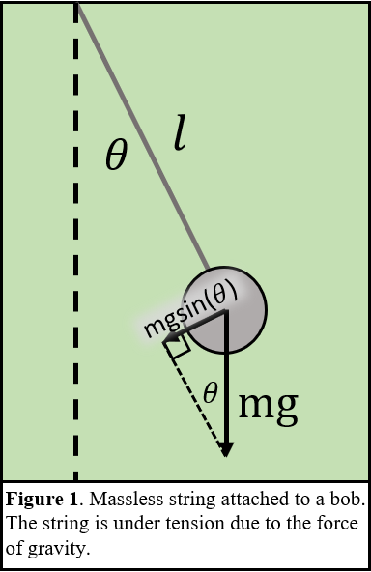To get the equation of motion (EOM) for this system we sum all the torques acting on the bob. In our experiment, we will consider only small angles of oscillation of the pendulum and thus use the first order approximation for . Here is the following EOM, using Newton’s notation for differentiation, where is the moment of inertia of the system, the length of the string, the angle from equilibrium position, the mass of the bob, Earth’s gravitational constant, respectively,

(1)

This equation simplifies to,

(2)

which is a linear 2nd order differential equation whose solution is a periodic sinusoidal solution, and the period of this function is given by,

. (3)

This model of our pendulum’s period is what we will first compare all our data to in this report.

**Damped Pendulum**

The bob moving through the air will lead to a different EOM because the air applies an additional torque resisting the motion of the bob. We presume that the force of the air on the bob is proportional and opposite in direction to the velocity of the bob, . Summing torques again leads to the following EOM where c is the resistivity of air,

(4)

Now we solve this differential equation for the underdamped case , because that is the only case we observe in our experiment. Which yields a period of,

. (5)

**Physical Pendulum**

In the above theories we assumed the mass of the string/fishing line to be massless. However, it does of course have some mass. To get the period we follow the same procedure as for the simple pendulum and sum the torques. The difference from the simple pendulum is that the moment of inertia and the distance to the center of mass has changed because we treat the fishing line as having mass. In that case, the period for the physical pendulum is:

. (6)

Where the moment of inertia for a cylinder rotating about one end is, . Here is the length of the fishing line (in our case) and is the distance from the point of rotation to the center of mass.

**EXPERIMENTAL DESCRIPTION**

We constructed our pendulum by cutting a piece of fishing line to length and tying it to a C-clamp, see Figure 2a. At the other end of the string, we tied it to the hook on our lead bob. Next, we added a rail near the bottom of its swing to ensure it was only swinging in a plane. To carry out measurements we need to measure the initial angle that the fishing line makes with respect to the rest position. So, we let it damp out and lined up the protractor with the fishing line then carefully taped it to the clamp, see Figure 2b. We added a lead brick so that we consistently pull the bob back to our desired angle every time.

At the beginning of the experiment, we made careful decisions about the dimensions of our experiment. We chose the length of our fishing line to be as long as possible so that we could maximize the arc length and easily observable large swings since we are oscillating at small angles. Then we chose the heaviest bob available to minimize the effects due to it being physical Diagram
pendulum.

**Measurements**

Before measuring the period of the pendulum, I will first state all the active components of our experiment. In Table 1, we report the mass of the bob, hook length of the bob, radius of the bob, g, and the last three columns are lengths of the fishing wire throughout the experiment.

|  |  |  |  |  |  |  |
| --- | --- | --- | --- | --- | --- | --- |
| Mass (grams) | Hook Length (cm) | Radius (cm) | g | Length (1/10) (cm) | Length (100) (cm) | Anharmonicity  Length (cm) |
| 315.750(5) | 0.5(5) | 1.887(25) | 9.80119 (0) | 186.45(30) | 186.69(30) | 142.61(30) |

**Table 1**. Active component values in our pendulum experiment with the errors.

*Bob Mass -* From left to right I will explain our measurement technique and its associated uncertainty. We measured the mass of our bob using a mechanical balance scale and a standard weight set. The uncertainty comes from the fact that the resolution of our measurement is dependent on the smallest weight we could balance it with. Once we got to the point where adding the smallest weight (10mg) unbalanced the scale, we stopped. Then took our number and put it in between 10mg.

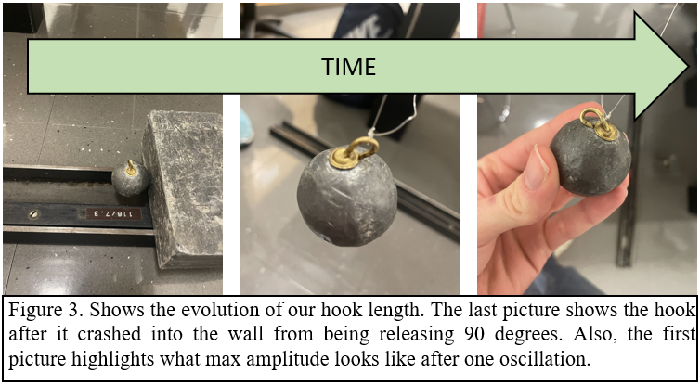*Hook Length* - Our hook length has a large uncertainty because it changed throughout the experiment, and we only measured it at the very end. Over time, due to unfortunate events, the hook length decreased from the maximally extended length to completely flat. So, we said the hook was half the maximally extended length and the uncertainty is half the hook length. Luckily, we took pictures of the hook length throughout the experiment, see Figure 3.

*Bob Radius* – We observed that the bob is not a perfect sphere and is rather asymmetrical. Using calipers, we measured the diameter of the bob along two directions perpendicular to one another. We then took the average and sample standard deviation of those values to be our nominal value and error.

*g* – Using WolframAlpha’s local gravity calculator [2] we found Earth’s gravity in Lincoln, Nebraska to be the value in Table 1. We quote no error because it was a not provided from the widget. It is also an order of magnitude more precise than (assuming it is correct up to the number of digits provided) than our length measurement.

*Length 1/10* - The first day we assembled our pendulum we measured it to be this length. We took 10 measurements and obtained the mean and standard error.

*Length 100* – After a few days passed we came to the lab gather the 100-period (see below for what that means) data and noticed it our bob was resting on our guide rail. Then, we tried to cut a new line to the length of the old one. We got close and used the same error from our first length measurements.

*Anharmonicity Length* – Unfortunately, we had to cut new line because our pendulum line snapped during the preliminary tests on how the period changes at different amplitudes (hence the name). In Figure 3, you can see the damage to the hook caused by this.

**Period Data**

Our experiment for measuring the period is divided into 3 categories: 1 period, 10 periods, and 100 periods. The initial angle for all these categories was maintained to be 5 degrees. We defined an oscillation as a full period swing where the bob returns to where we released it at 5 degrees.

***1 Period:*** The pendulum swung for only 1 oscillation then recorded the time with a stopwatch. We repeated this measurement 10 times.

***10 Periods:*** The pendulum swung 10 times then recorded the time with a stopwatch. We repeated this measurement 10 times. This whole process was repeated 9 times to get a total of 9 datasets with 10 points each.

***100 Periods:*** The pendulum swung 100 times then recorded the time. We repeated this measurement 10 times to arrive at a single dataset with 10 points.

**Sources of Error**

For this report we categorize 2 types of errors present in this experiment: random error, and systematic error.

*Random error* ***-*** Random error is defined by error that varies from measurement to measurement. Random error is characterized by the width of our histograms (presented later). The largest expected source of random error that enters the experiment is when measuring the period. Since we must watch the bob reach its maximum amplitude and make a judgment call on when to stop the stopwatch. Another effect is that our bob is not perfectly spherical and every time we pull it back the center of mass shifts slightly between measurements. But I think we can safely assume this is a negligible effect.

*Systematic errors* ***–*** Two, of the many, sources of systematic error that we will explore in this report are outlined in the theory: are damping due to friction and the physical pendulum. To test the physical pendulum model, we will look at what the theory predicts the period to be and compare with the data. Another source of systematic error is our low angle approximation. All these errors are legitimate, but it is unclear how much they affect our experiment. Measurements of the components of our experiment also introduce systematic error since we cannot measure length and mass with infinite precision. For these we are constrained by the tools we used to measure them.

**Data for the Anharmonicity of a Pendulum**

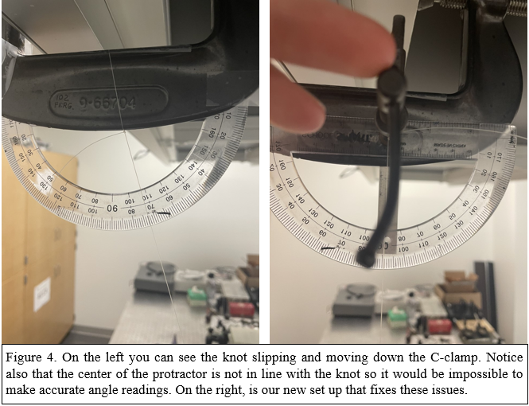To test the anharmonicity, we conducted an experiment where we take the bob to large angles where the approximation fails and let the pendulum swing for 10 periods. We repeated this experiment 5 times for each given angle.

Since our fishing line snapped during preliminary tests of this experiment, we needed to cut new line. An error in our first experimental set up was the center of the protractor is not parallel with the axis of rotation of the pendulum. Another oversight was the axis of rotation of our pendulum would slide around the C-clamp at high angles. In Figure 4, you can see our new pendulum set up fixed both issues by putting the axis of rotation on a cylinder, so it doesn’t slide around, and we lined up the protractor with the axis of rotation.

**Data for Damped Oscillator**

To test the damping effect, we conduct an experiment where we let the pendulum swing for 10 periods (for a given angle) and record the decrease of the amplitude by looking at the protractor as the pendulum swung.

**Data for Physical Pendulum**

Get the moment of inertia and stuff…

**RESULTS**

Data results all histograms for each

Interpretation of data (error propagation)

What sources of error dominate? If none of suspected systematic errors where else?

Human error defined by width of histograms

Anharmonicity results

Systematic error evaluation (anharmonicity, damped pendulum, physical pendulum)

**DISCUSSION**

References:

[1] <https://www.britannica.com/technology/pendulum>

[2] <https://www.wolframalpha.com/widgets/view.jsp?id=e856809e0d522d3153e2e7e8ec263bf2>